

No . 1018.2/40

TO WHOM IT MAY CONCERN:
This is to certify that ชื่อ-นามสกุล ภาษาอังกฤษ is a recipient of the Royal Thai Government Scholarship under the supervision of the Office of the Civil Service Commission which is responsible for her educational and living expenses while studying in France.
Upon completion of the academic program, the recipient will immediately return to her post in Rajamangala University of Technology Suvarnabhumi where she is legally obliged to work there not less than twice the period of her study in France.
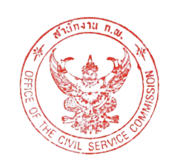


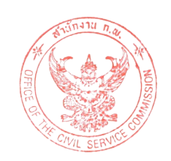



Office of the Civil Service Commission

Nonthaburi 11000, Thailand






January 8, 2026



Education and Training Abroad Center
Office of the Civil Service Commission
Tel: (66) 2547 1737
Fax: (66) 2547 1800

